**Insights and Reporting: Social Media Sentiment Analysis**

This report provides insights into a social media sentiment analysis dataset. The data includes information on comments, hashtags, platforms, and sentiment.

**Top Hashtags:**

* The chart below shows the top 50 most frequently used hashtags. This helps identify trending topics and discussions within the dataset.

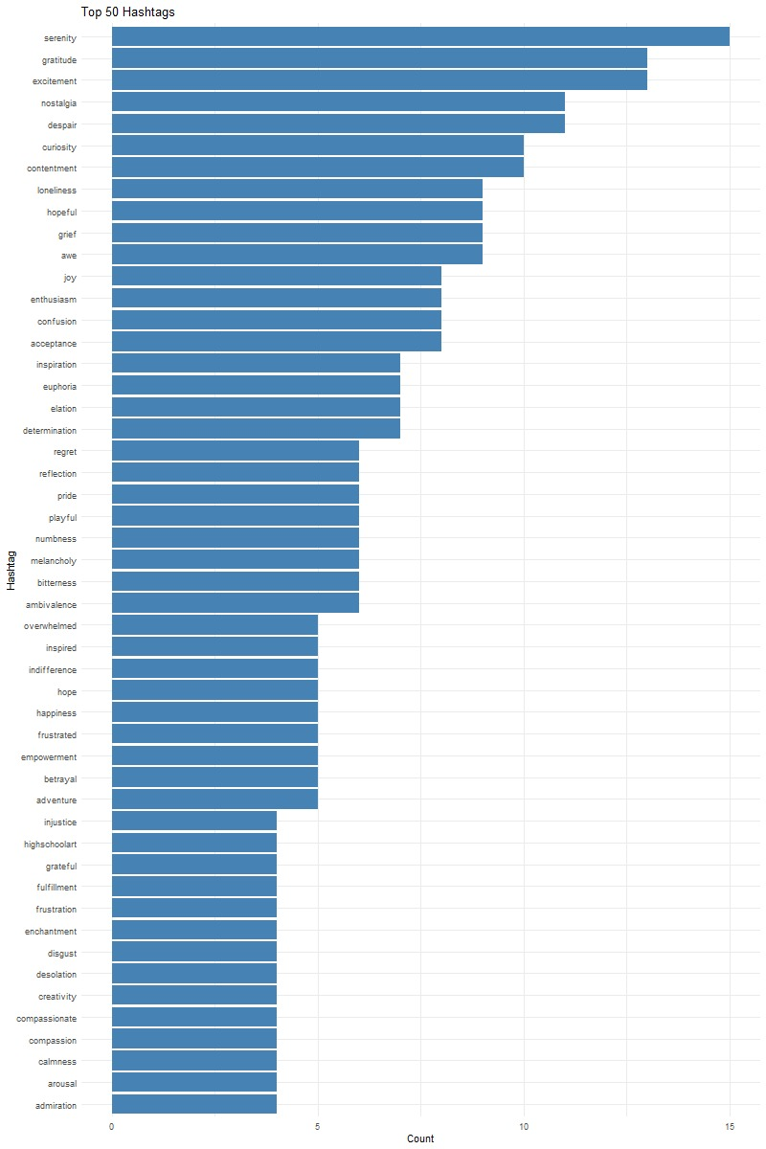

**Platform Engagement:**

* This bar chart displays the distribution of posts across different platforms. It helps understand which platforms generate the most content within this dataset.

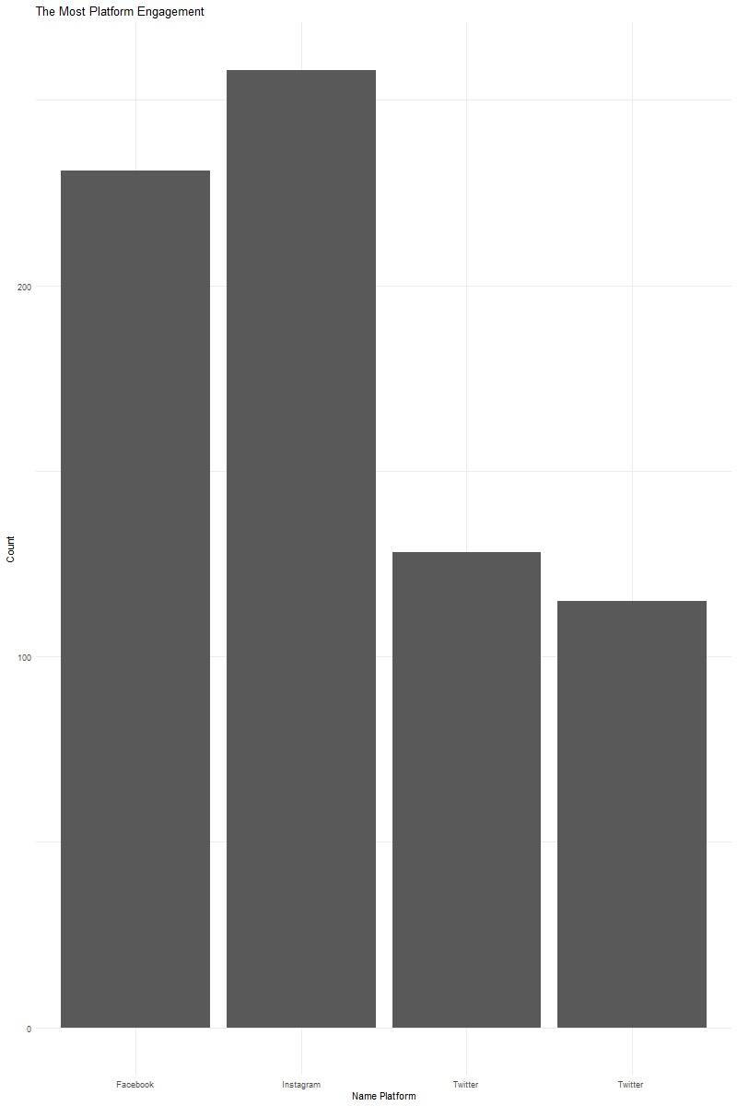

**Word Frequency in Comments:**

* This chart analyzes the most frequent words used in comments, focusing on positive and negative sentiment words. It provides insights into the overall sentiment and the specific emotions expressed.

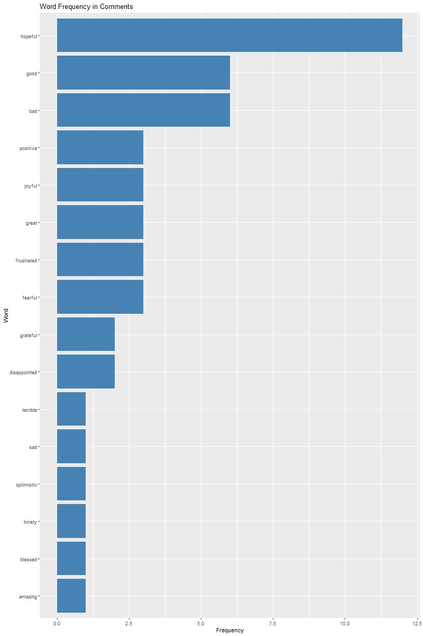

**Sentiment Distribution:**

* This bar chart shows the distribution of positive, negative, and neutral sentiment across the comments. It helps understand the overall sentiment towards the topics discussed.

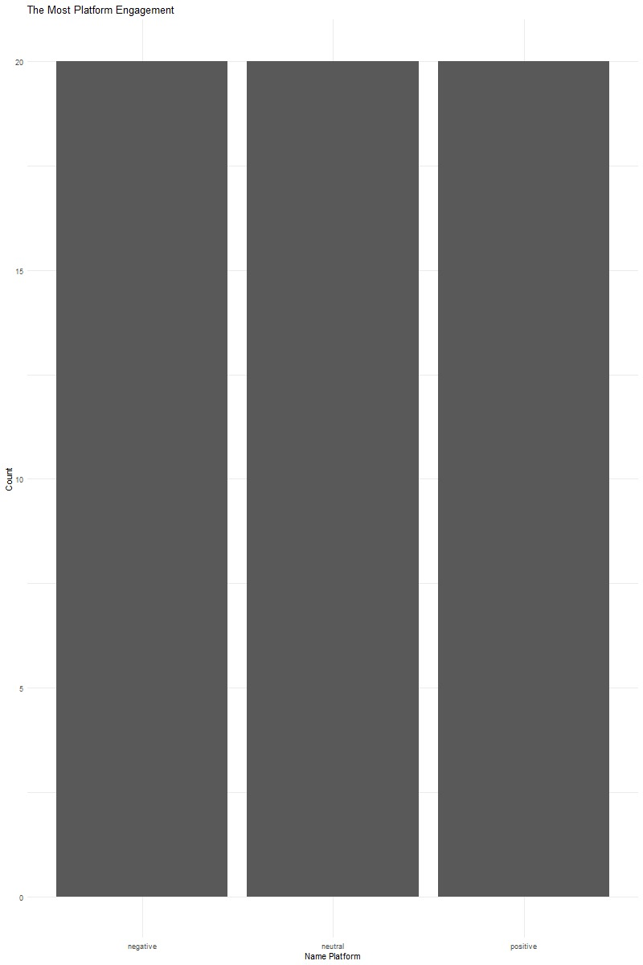

**Most Liked Posts by Hour:**

* This line graph identifies the hour of the day when posts receive the most likes. This information can be valuable for optimizing posting times based on user engagement patterns.

